Faraby(Doomguy) is teamlead.
Madina(Bayonetta) is Lady Killer.
Alua(Niko) is mastermind.

Week | Tasks | Expected start date | Finishing date | Responsible  team member
1/11/2019 | DB of users/articles/  admin/(thread) | 28/10/2019 | 1/11/2019 | Faraby
1/11/2019 | Create base classes(users  /articles/admin) | 28/10/2019 | 1/11/2019 | Alua
1/11/2019 | Base page(  News hypertext, login screen) | 28/10/2019 | 1/11/2019 | Madina
8/11/2019 | Log/Reg /User page/ make comment) | 1/11/2019 | 8/11/2019 | Alua
8/11/2019 | Articles/Blog Pages Add/Delete/Edit | 1/11/2019 | 8/11/2019 | Madina
8/11/2019 | Add Game page | 1/11/2019 | 8/11/2019 | Faraby
15/11/2019 |  | 8/11/2019 | 15/11/2019 | Madina
15/11/2019 | Improve Game pages | 8/11/2019 | 15/11/2019 | Faraby
15/11/2019 | Comment/ Ban users/Thread | 8/11/2019 | 15/11/2019 | Alua
22/11/2019 | Wrapping / Improving your parts | 15/11/2019 | 22/11/2019 | Madina
22/11/2019 | Improving User Page(Follow,Improved news) | 15/11/2019 | 22/11/2019 | Alua
22/11/2019 | Wrapping / Improving your parts | 15/11/2019 | 22/11/2019 | Faraby
29/11/2019 | TroubleShooting | 22/11/2019 | 29/11/2019 | Madina
 |  |  |  | Faraby
 |  |  |  | Alua

Project Cyber_News
1. Why this topic was chosen.
We chose the topic of Game Reviews/News because it is interesting topic for us and relevant topic in the current days. Cyber_News will be able to bring it’s users video game news, reviews about big and indie companies and their titles in the industry and nice atmosphere between users and content creators. We offer coverage about everything, from PlayStation and Xbox exclusives to the most exciting Nintendo Switch games, and more. Whether you’re a PC gamer, console addict player, we’ll try to provide you with what you will need to keep up with today’s fast-paced gaming world, or to dive deep into the world of more obscure side of industry. This topic is intriguing to us because as students, Cyper_News will be close to our interests and will help us to improve our skills in web programming. We hope that this will be enough to drive this project until the end.

2. Project auditory.
Cyber_News will target every hardcore, old school or casual gamers, or in one word everyone who will be interested in every aspect of gaming industry, and will participate in creation of friendly community of Cyber_News readers.

3. Project features.
WebPage Composition:
Main Page:
- Contains web page logo,
- Navigation
- Articles
- Threads
- Games
- Search,
- Sing in/Sign out
- List of popular or new articles
- Blogs
Game Page:
Contains main information about a particular game:
- Name
- Photo
- Platform
- Release date
- Publisher
- Rating
- Link to Articles
- Link to Blogs
- Threads(?)

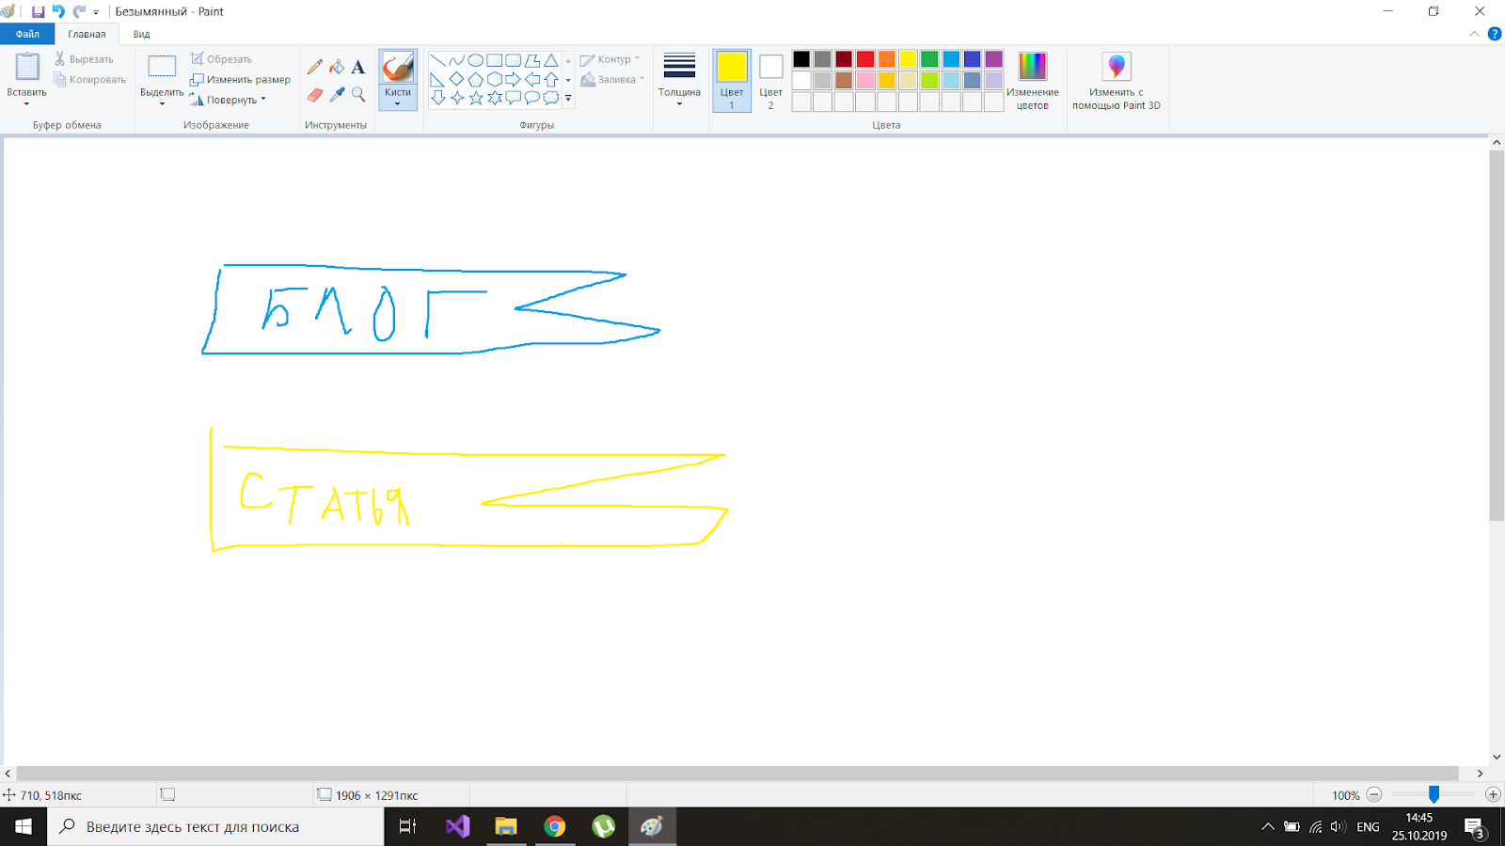
Articles:
- Article symbol
- Title
- Author name
- Date
- Photo(optional)
- Game link
- Text
- Comments section
- Turn off comments(?)
Blog:
- Blog symbol
- Title
- Author name
- Date
- Photo(optional)
- Game link
- Text
- Comments section
- Turn off comments(?)
Thread:
- Game related to topic
- Head comment
- And all other comments (sorted from newest to oldest)
- Can be closed by creator(?)
Comment:
- Have Author
- Can be only upvoted
- Can be edited
- Can refer to another comment from same section/page
User page:
- Login
- Avatar(?)
- Links to his own content
- Links to the preferred:
  - blogs
  - articles,
  - threads.
Moderator page:
- Login
- Avatar(?)
- Links to own content
- Notification box
- List of all users.
- Ban user
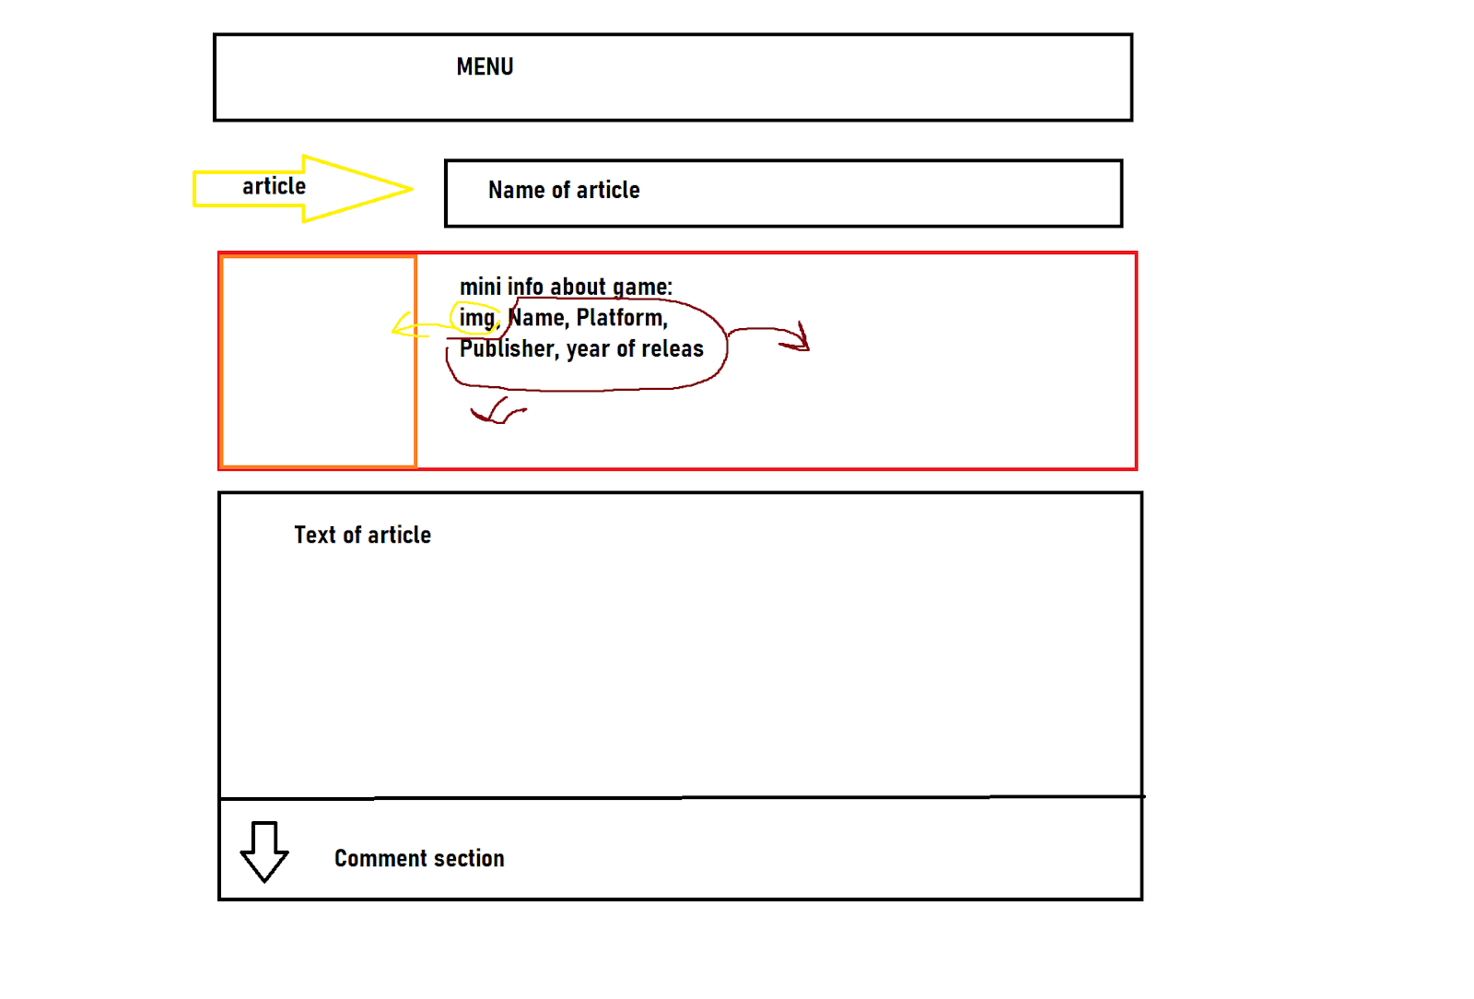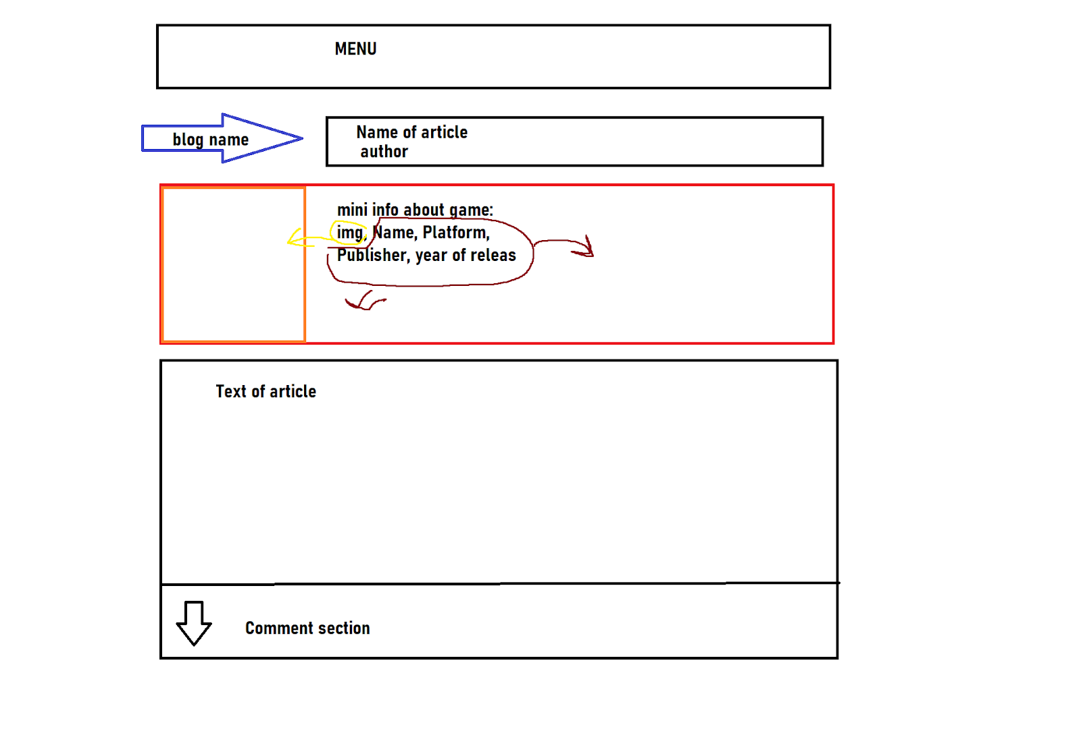
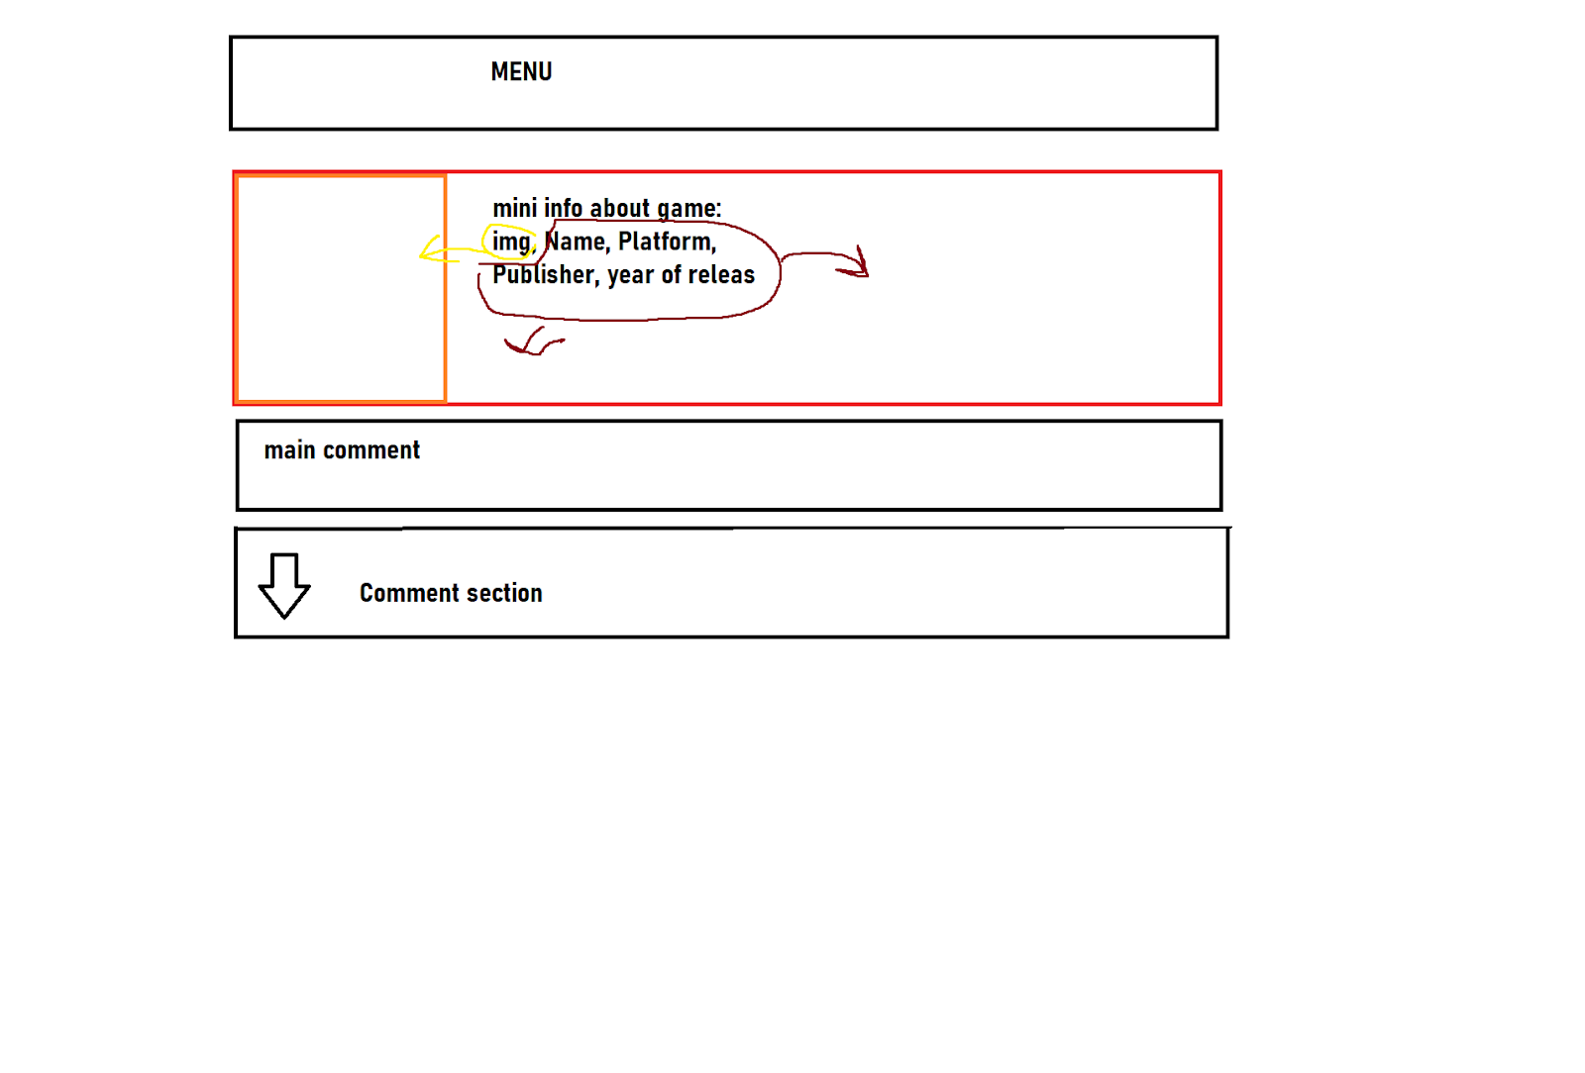
4. Similar projects in Kazakhstan and to which extent your app can be competitive against these projects.
We couldn’t find similar projects from Kazakhstan, so we decided to use Russian project “StopGame” as the main course. “StopGame” is a site, which mostly focuses on topics around video games, video gaming industry and other relatable to this topic news. They also produce their own content, aside from the current state from the industry or upcoming games, like History of a Series(“История Серии”), Flight Analysis(“Разбор Полетов”), and help to promote content from users, sharing it with other readers. But “StopGame” focuses not only in gaming news, and user blogs. This is, where we want to make difference. We are going to focus mainly on content related to games or user base, that will talk about video games. We are not going to make so called “Cold Professional Gaming News” site, but rather create place where you can find, read and talk about games in a friendly community of people.

Colour scheme:
https://colorscheme.ru/#47524w0w0w0w0

